EXP 3- MATLAB Analysis of Spectrum Bands, Propagation Loss and Cellular Interference
Aim:
To compare a simplified free-space path-loss estimate across representative sub-1 GHz, midband and mmWave frequencies, and examine how distance and frequency reuse affect received signal and simple interference measure.
Objectives:
1. Calculate or simulate path loss at representative sub-1 GHz, mid-band and mmWave frequencies.
2. Compare estimated received signal strength as frequency and distance change.
3. Examine how cell separation or frequency reuse changes a simplified interference ratio.
4. Relate the results to coverage and spectrum-use considerations across mobile generations, while stating model limitations
Procedure:
1. Run the script and inspect the path-loss and received-power plots.
2. Record the estimated received power at 0.5 km for each frequency.
3. Inspect the reuse-SIR plot and compare the baseline N values.
4. Change transmit power, distance range, path-loss exponent or reuse sizes; rerun and record the effect.
5. Explain why frequency reuse changes the simplified co-channel SIR and why the freespace link budget is not a complete coverage prediction

PROGRAM:
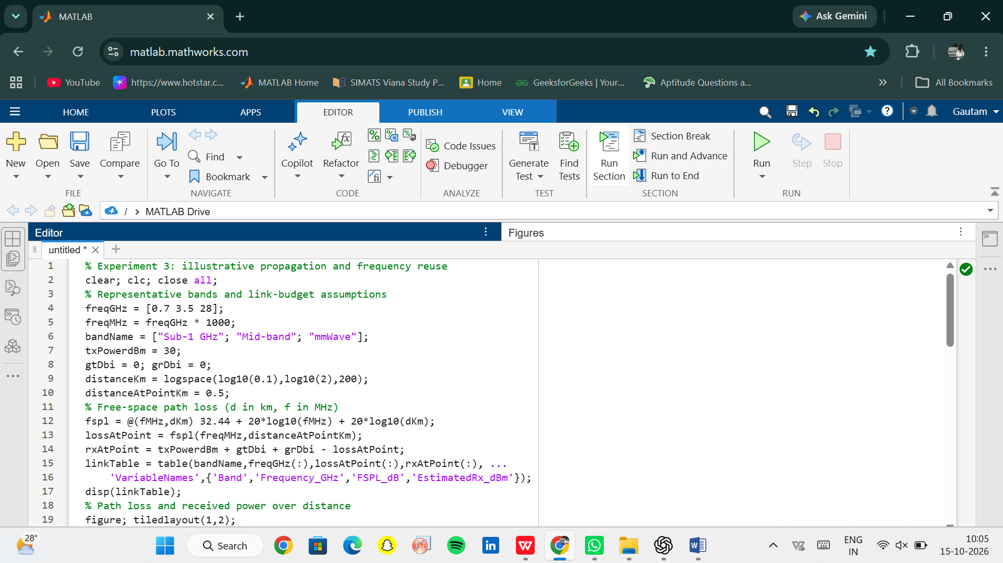
OUTPUT:
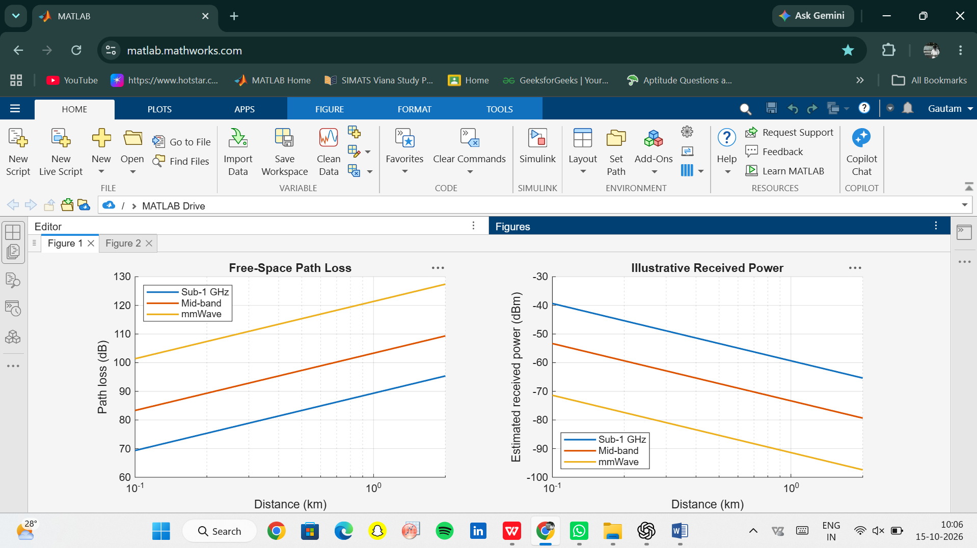

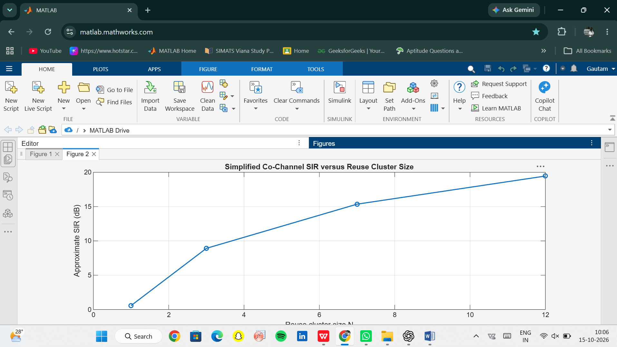

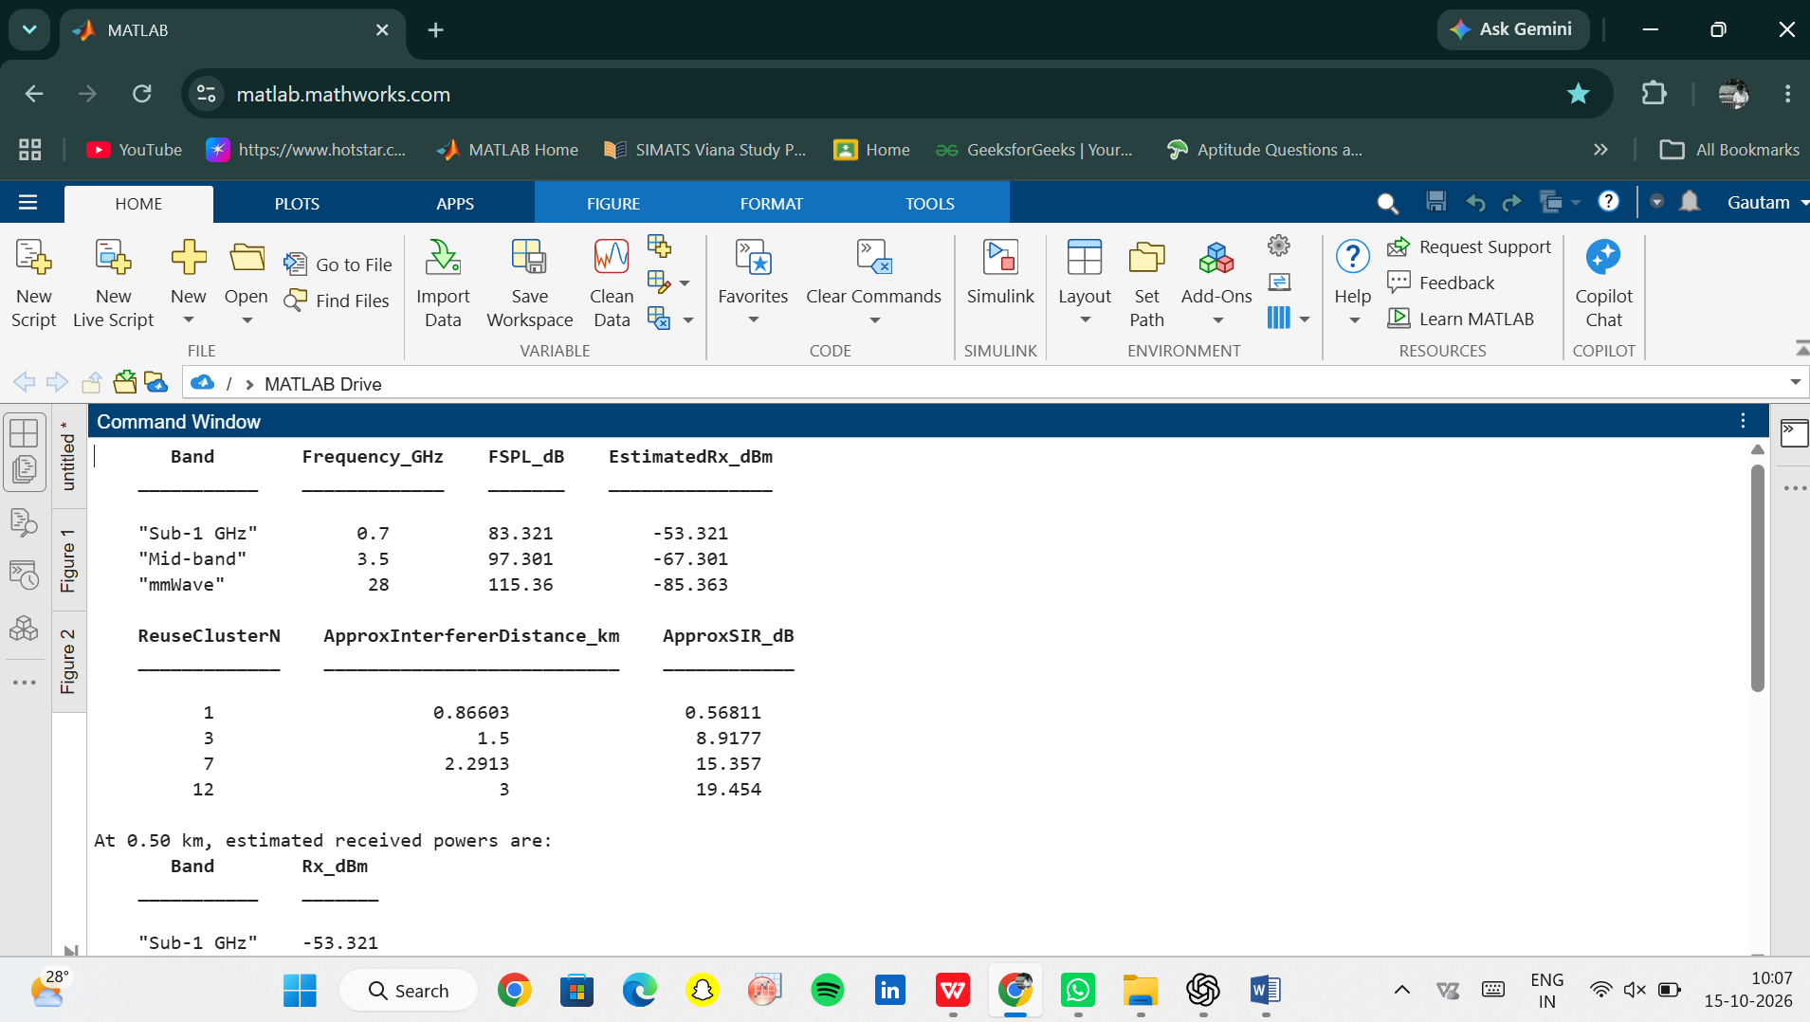

Conclusion:
Summarize the frequency and distance trends from the simulation and the effect of reuse separation on the illustrative SIR. Identify the free-space assumption, fixed transmit power and idealized six-interferer geometry as limitations. Note that practical coverage depends on antenna characteristics, environment, bandwidth, receiver sensitivity, interference, regulatory constraints and the chosen propagation model.

